WEEK 4
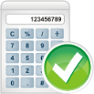
- The area of a farm is 56 823 km². What is this area to the nearest thousand square kilometres?
57 000
- 36 ÷ 12 = 12 ÷ 4 What is 4 ?

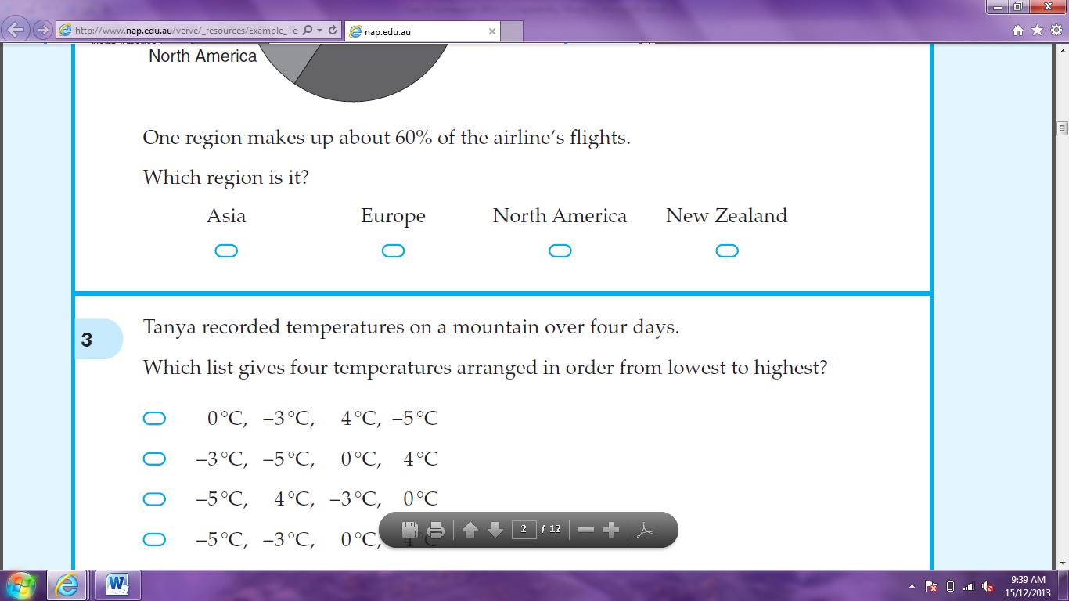
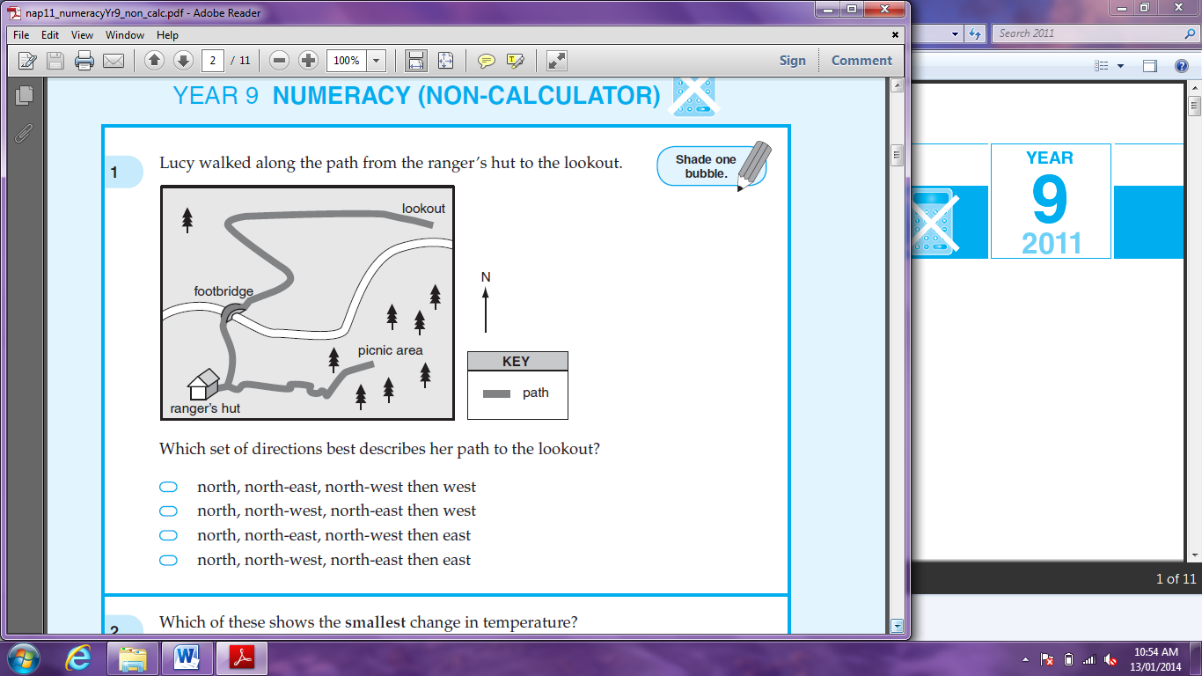
- Lucy walked along the path from the ranger’s hut to the lookout. Which set of directions best describes her path to the lookout?

north, north-east, north-west then west

north, north-west, north-east then west

north, north-east, north-west then east
north, north-west, north-east then east





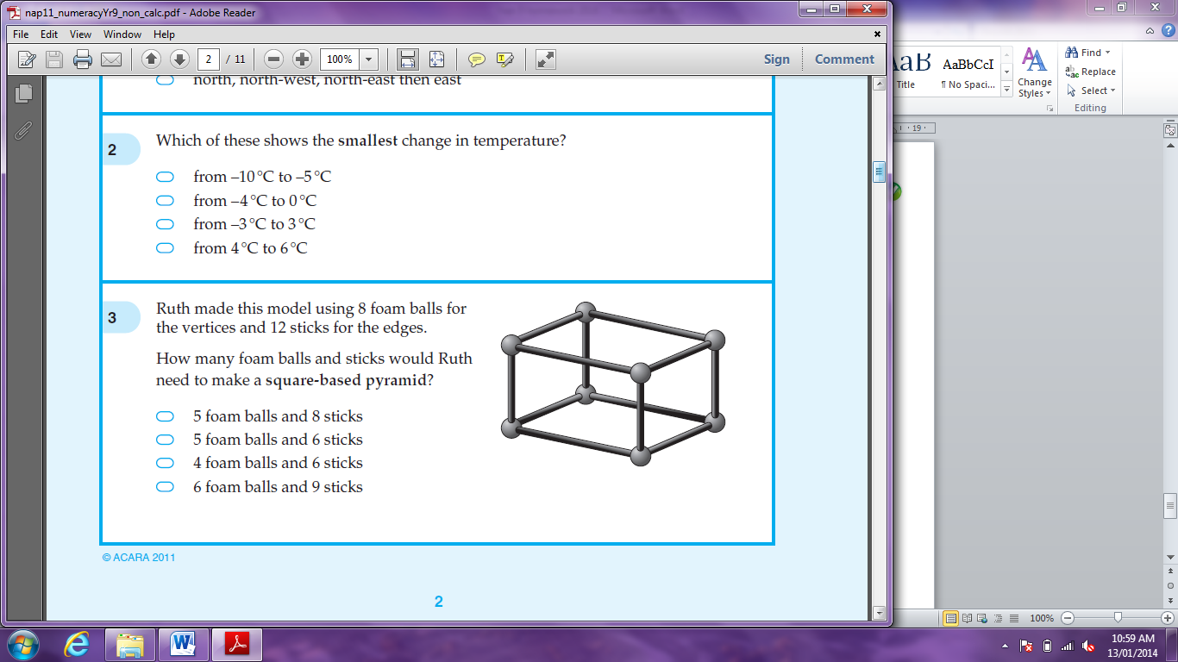
- Ruth made this model using 8 foam balls for the vertices and 12 sticks for the edges. How many foam balls and sticks would Ruth need to make a square-based pyramid?
5 foam balls and 8 sticks
5 foam balls and 6 sticks
4 foam balls and 6 sticks
6 foam balls and 9 sticks

- The number of customers at a store in an hour (over 5-minute intervals) was recorded:
0, 1, 2, 2, 4, 5, 7, 7, 7, 8, 8, 9
What was the median? 6

- What is the perimeter of this shape?
24m

- What fraction of 36 is 24?$\frac{2}{3}$
- Which of these numbers is losest in value to ?
0.5 0.6 0.7 0.8 1.2






- After 6 games, Shaun’s average (mean) number of points scored per game was 3.5. How many points had Shaun scored all together? 21

- A positive number was multiplied by itself. The answer was 8649. What was the number? 93

- Together a loaf of bread and a packet of biscuits cost $5.50. The bread cost 50 cents more than the biscuits. How much was the bread?
$3

- This diagram is made up of a rectangle and an equilateral triangle. What is the value of x?

150$°$

- 200 = 1000 - . What is the value of n?
3200

- Yesterday, Alison completed 25 laps of the pool. Today she completed 30 laps. What percentage increase is this?
20%
- Jess and Jo share $3600 in the ratio of 5 to 4. What is Jo’s share?
$1600

- Mike sells cars. His weekly salary, S dollars, is calculated using this rule:
S = 500 + 0.02V
where V is the total value in dollars of the cars he sells in that week. Last week, the total value of the cars Mike sold was $120 000. What was Mike’s salary last week? $2900

- Which expression is equivalent to 3(1 – p) – p?




3 – 2p 3 – p² 3 – 4p 3 + 2p

- 7f + 8 = 5f – 4. What is the value of f? f=-6

- A polygon has two angles of 90° and its remaining angles are all 135°. What type of polygon is it?




Pentagon hexagon octagon decagon

